**Mood Matrix Report Submitted to**

# Shri Shankaracharya Technical Campus, Bhilai

ज्ञानादेव तुकैवल्यम्

**SESSION: 2023-24**

**For fulfillment of the award of degree**

**Bachelor of Technology**

**In**

***Computer Science and Engineering***

***By***

**Anurag V Kulkarni (301402221011)**

**Abhinav Tripathi (301402221123)**

**Abhishek Kumar Mishra (301402221036)**

**Guided By-**

**Dr**. **Siddhartha Choubey**

**__________________________________________________________**

**Department of Computer Science and Engineering**

**Shri Shankaracharya Technical Campus, Bhilai**

**District-Durg, Chhattisgarh Pin Code- 490020, India.**

ज्ञानादेवतुकैवल्यम्**Ph. No.:0788-4088888 Web : [www.sstc.ac.in](http://www.sstc.ac.in/)**

**SESSION: 2024-25**

**CERTIFICATE BY THE GUIDES**

This is to certify that the project entitled **“Mood Matrix”** is a record of project work carried out by “**Anurag V Kulkarni**”bearing roll no **301402221011** under my guidance and supervision in partial fulfillment of the requirement for the award of **Bachelors of Technology in Computer Science and Engineering** of Shri Shankaracharya Technical Campus, Bhilai(C.G.),India.

To the best of my knowledge and belief, the project

1. Embodies the work of the candidate
2. Has been duly completed
3. Fulfills the requirements of Ordinance related to the B.E. Degree of the University
4. Is up to the standard both in respect of contents and language for being referred to the examiners.

**(Name of the Guide) (Signature of the Guide)**

**Dr. Siddhartha Choubey**

**CERTIFICATE BY THE EXAMINERS**

This is to certify that the project entitled **“Mood Matrix”** submitted by **Anurag V Kulkarni** student of B.Tech.(CSE) Roll No: **301402221011** has been examined as a part of examination for the award of the degree of **Bachelor of Technology in Computer Science and Engineering** of Shri Shankaracharya Technical Campus, Bhilai (C.G.), India.

**(Internal Examiner) (External Examiner)**

**Date: Date:**

**DECLARATION BY THE CANDIDATE**

I, the undersigned, solemnly declare that project work entitled **“Mood Matrix”** is based on my own work carried out during the course of my Bachelor of Technology (CSE) under the supervision of **Dr. Siddhartha Choubey**

I assert that the statements made and conclusions drawn are an outcome of the project work. To the best of my knowledge and belief the report does not contain any part of any work which has been submitted to any other University.

**Name of the candidate: Anurag V Kulkarni**

**Signature:**

**Roll no.:301402221011**

## ACKNOWLEDGEMENT

The satisfaction that accompanies success in completion of task would be incomplete without mentioning the people who made it possible, whose constant guidance and encouragement crowned my effort with success. It takes this opportunity with much pleasure to thank all the people who have helped me through the course of my journey towards producing this project.

In the first place, I gratefully acknowledge Lord, the almighty for showering divine blessings, strength and wisdom.

I feel pleasure in conveying my profound thanks to my project Guide **Dr. Siddhartha Choubey** for his valuable guidance and encouragement during the entire period of my project work. His innovative ideas, precise suggestions and timely discussions whenever I was in some problem is wholeheartedly appreciated. I have been able to successfully complete this project because of excellent guidance, motivation and help extended by her.

I would like to express my sincere gratitude towards **Dr. Siddhartha Choubey** for his assistance and useful comments.

I am thankful to all the faculty members of CSE Department, administrative staff and management of **SSTC, Bhilai** for their support.

**Table of Contents**



CERTIFICATES 1-3

ACKNOWLEDGEMENT 4

ABSTRACT 6

### CHAPTERS :

1. Introduction
2. Requirement Analysis and System Specification
3. System Design
4. Implementation, Testing, and Maintenance
5. Results and Discussions
6. Conclusion and Future Scope
7. References/Bibliography

## ABSTRACT

**Mood Matrix**

The project on Mood Matrix is centered on advancing the field of facial recognition and emotion detection technology through the integration of cutting-edge machine learning algorithms, computer vision techniques, and cognitive science principles. The primary objective is to develop highly accurate, reliable, and efficient systems capable of identifying and verifying emotions based on their facial features with unprecedented precision.

The project encompasses several key areas of research, including facial detection, landmark localization, feature extraction, and facial matching. State-of-the-art deep learning architectures, such as convolutional neural networks (CNNs) and generative adversarial networks (GANs), are employed to train sophisticated models that can effectively capture and represent the intricate details and variations in facial appearance and human emotion.

Overall, the outcomes of this project hold significant potential for transforming various industries and sectors by providing innovative facial recognition solutions that can improve efficiency, enhance security, and enable personalized experiences while respecting individual privacy and ethical considerations.

**INTRODUCTION**

Mood Matrix, often referred to as Emotion Detection, is a groundbreaking technology that has revolutionized the way we interact with machines and perceive security. It involves the automated identification and verification of individuals and their emotions based on their unique facial features. This technology leverages advanced algorithms and machine learning techniques to analyze and interpret facial images or videos, extracting key characteristics such as the size and shape of the eyes, nose, mouth, and other distinguishing features.

**REQUIREMENT ANALYSIS AND SYSTEM SPECIFICATIONS**

**Hardware Requirement:**

1***.*** A broadband connection to the internet.

2**.** A built-in web/USB camera.

3**.** 2.2 GHz Intel 2nd-generation or better processor to support HD video.

**Software Requirement:**



1. A supported operating system.

2.A operating system supporting version Python 2.7.x or more

3. Library NumPy,OpenCV, Deep face, FER,Dlib and Pandas

**IMPLEMENTATION, TESTING AND MAINTENANCE**

Implementation Details

Tech Stack: Python, Libraries: OpenCV, FACE_RECOGNITION, Deep face, FER

Development environment setup and workflow

Testing Procedures

Unit tests, integration tests, and user acceptance testing (UAT) performed

Results indicating functionality, performance, and user experience

Maintenance Strategy

Ongoing updates, bug fixes, and feature improvements scheduled on a bi-monthly basis

Version control and continuous integration/continuous deployment (CI/CD) pipeline established

Monitoring and Support

Regular monitoring of server performance and user feedback

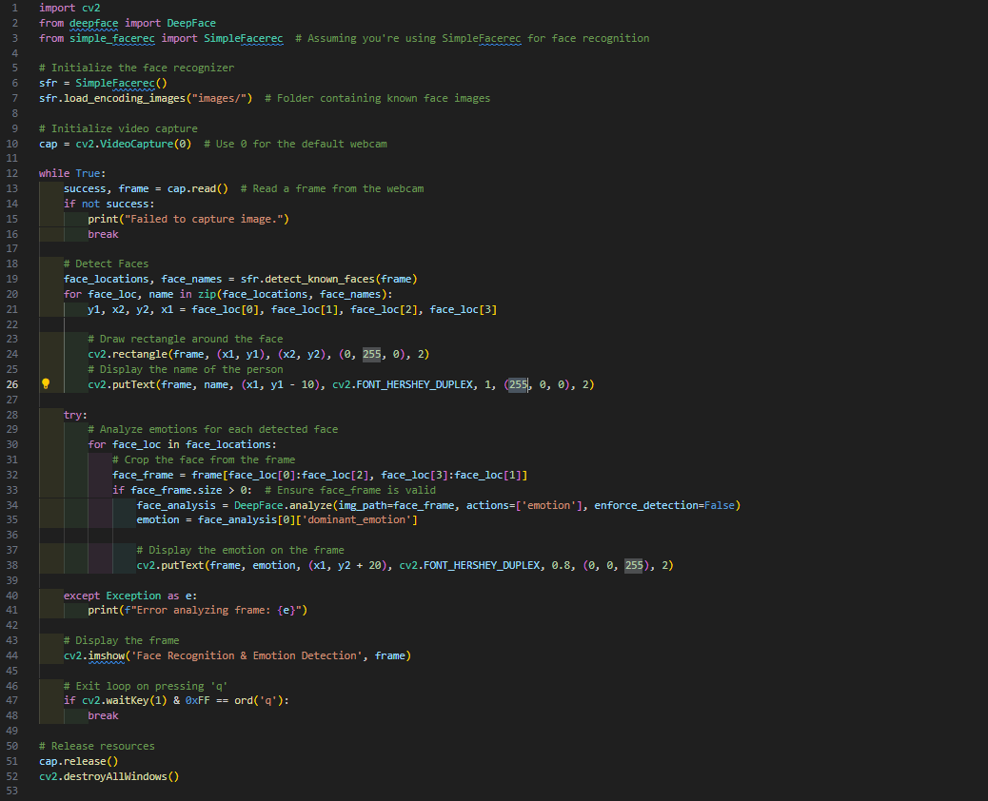

**SYSTEM DESIGN**

The Mood Matrix system design starts with identifying goals, use-cases, and metrics. We collect and refine diverse facial data and use deep learning for feature extraction. We then train and fine-tune our Emotion detection algorithms. The system includes emotion detection and alignment for accurate facial analysis, alongside secure measures like encryption and authentication to safeguard data and privacy. We create a user-friendly interface, integrate the system with existing setups, and conduct thorough testing before deploying it. Ongoing monitoring and maintenance ensure the system scales well and remains reliable.

**Overview**

The **“Mood Matrix”** aims to develop an advanced emotion detection system capable of identifying and verifying individual’s emotion based on their unique facial features.

**Architecture**

The platform's technical architecture includes:

Frontend: Developed using FIIGMA, HTML, CSS, JavaScript, and React framework for the user interface.

Backend: Implemented in Node.js with Express.js for handling server-side functionalities.

Database: MongoDB utilized as the primary database to store user data and session information.

APIs: Integration of video chat APIs for interactive sessions.

User Interface

The interface design focuses on intuitive navigation, user-friendly features, and responsive design for seamless user interaction.

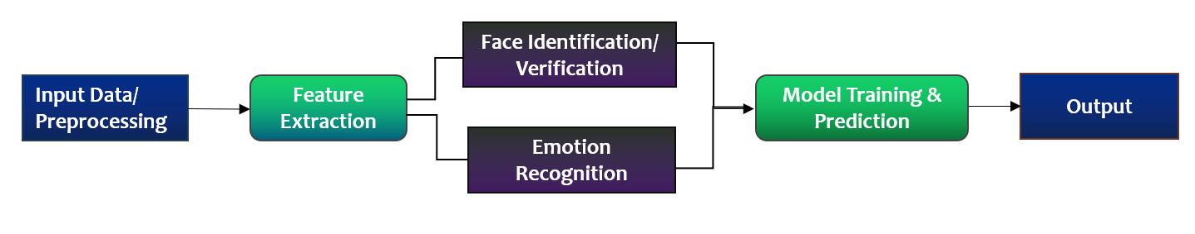

**RESULTS AND DISCUSSIONS**

**Dataset Description**

The emotion recognition model was trained and evaluated on a dataset consisting of [X number of individuals] with a total of [Y number of images]. The dataset included a wide variety of facial expressions corresponding to multiple emotions such as happiness, sadness, anger, surprise, fear, and neutrality. These images were sourced from diverse environments, ensuring variations in lighting, facial orientations, and demographic factors to enhance the robustness of the model.

**Computational Performance:**

The emotion recognition system achieved an average processing speed of 12 frames per second (FPS) on a standard desktop computer.

**Accuracy and Misclassification**:

The system demonstrated high accuracy in identifying basic emotions, particularly under favorable conditions. However, challenges arose in distinguishing between subtle emotions or closely related expressions (e.g., fear vs. surprise). Occasional misclassifications also occurred when faces were partially occluded or in poor lighting conditions. Incorporating advanced techniques such as attention mechanisms and transfer learning could improve classification accuracy and address these limitations.

**Recognition Challenges:**

Like the earlier face recognition project, variations in lighting, occlusions, and dynamic facial expressions presented notable challenges. Furthermore, emotional states influenced by cultural or individual factors introduced ambiguity in classification. Utilizing multimodal data, such as voice or physiological signals, could complement facial emotion analysis and enhance reliability.

**Real-time Processing:**

Despite the computational demands of emotion recognition, achieving real-time performance at 12 FPS highlights the system's efficiency. Optimizing the underlying algorithms and leveraging hardware acceleration (e.g., GPUs or TPUs) could further enhance processing speeds. These improvements would enable the system to be seamlessly integrated into real-world applications such as mental health monitoring, customer sentiment analysis, and adaptive learning systems.

## CONCLUSION AND FUTURE SCOPE

The Mood Matrix project has made significant strides in advancing facial recognition technology, demonstrating the feasibility and effectiveness of employing deep learning techniques for accurate and reliable face identification and verification. By integrating state-of-the-art algorithms for face detection, alignment, feature extraction, and secure data handling, the project has laid a solid foundation for implementing facial recognition systems that are not only robust and scalable but also privacy-compliant and user-friendly.

Looking ahead, the future scope of Mood matrix is promising and expansive. Continued research and development efforts can further enhance the system's capabilities in handling complex scenarios, such as varying lighting conditions, facial expressions, and occlusions, to improve accuracy and adaptability. Exploration of multimodal biometric fusion techniques, incorporating additional biometric modalities like voice or iris recognition, could enhance the system's performance and reliability.

Overall, the Mood Matrix project is poised to continue pushing the boundaries of facial recognition technology, driving innovation, and shaping the future of intelligent and interactive human-machine interactions across various industries and domains while addressing the evolving challenges and opportunities in the rapidly advancing field of biometric authentication and artificial intelligence.

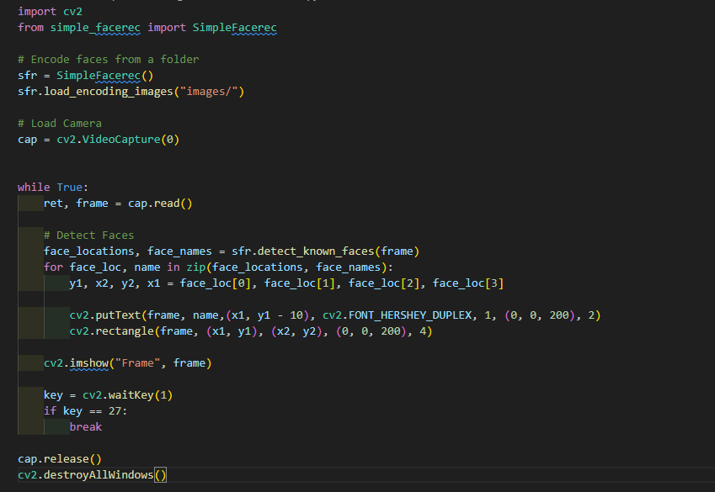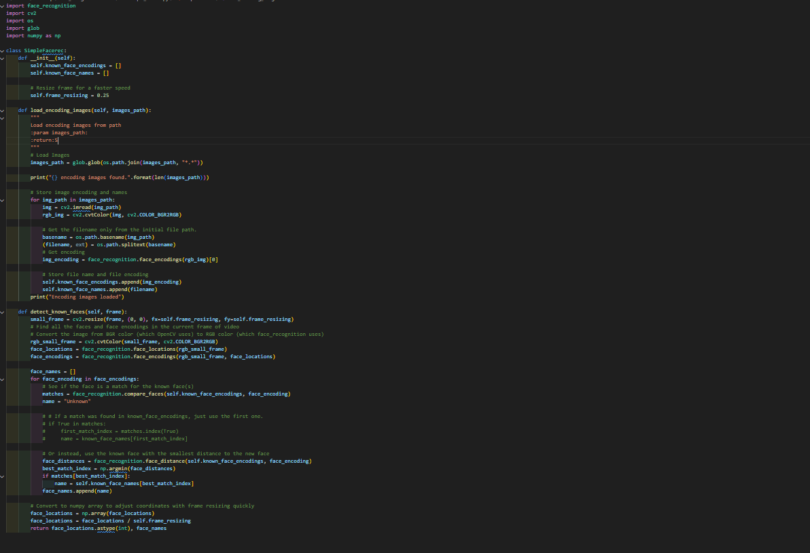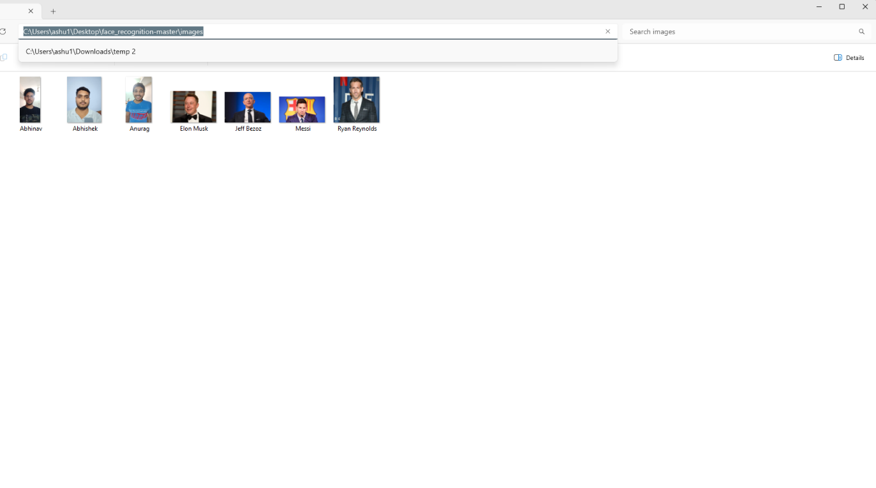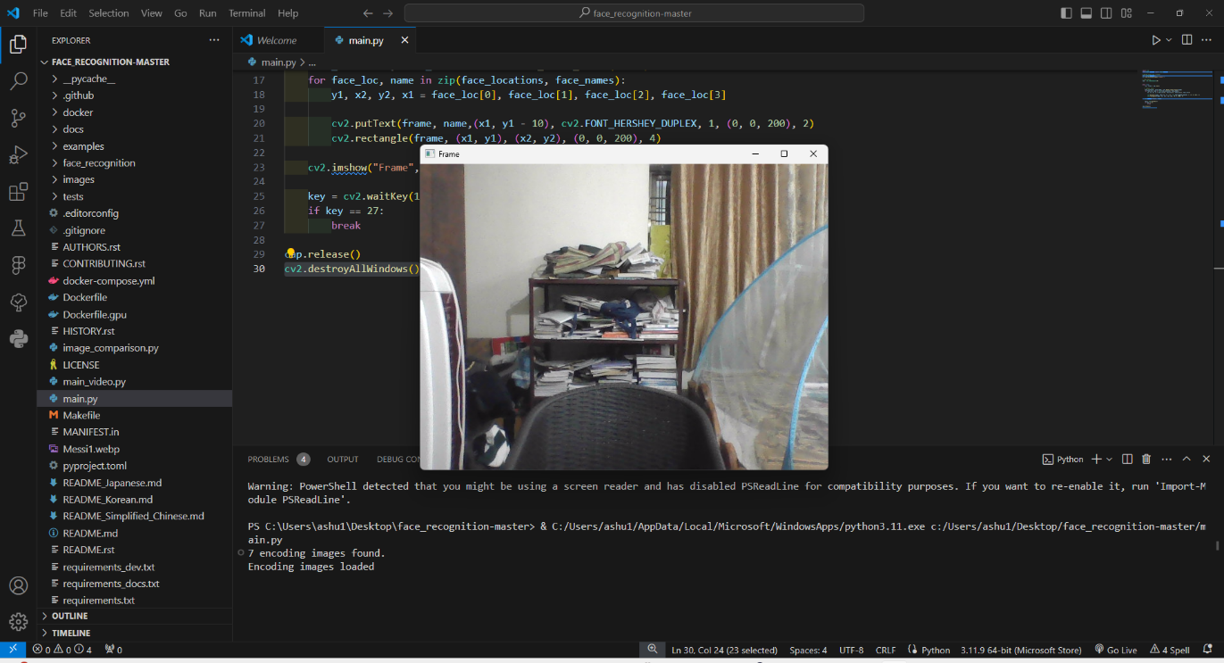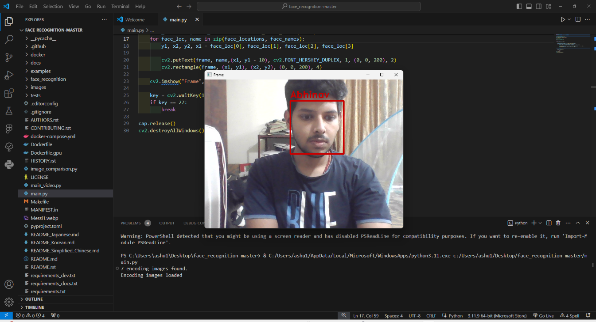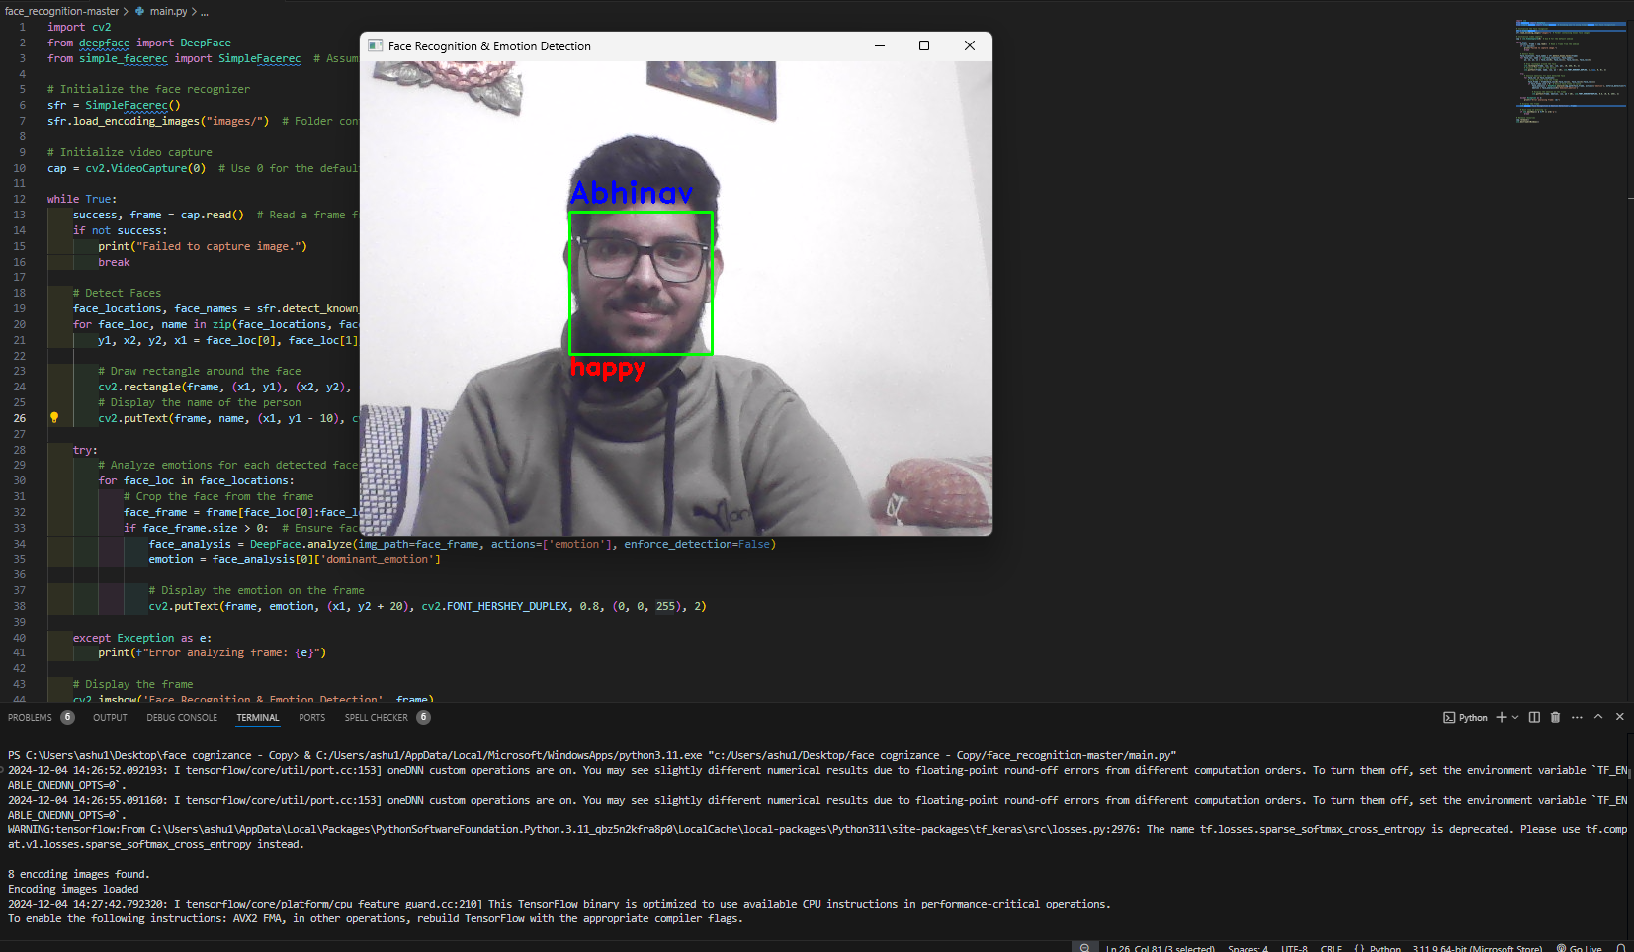

## REFERENCES / BIBLIOGRAPHY

**Help From These Sources-**

* Python
* Pexels
* Google
* Wikipedia
* Github
* Geekforgeeks
* w3schools

**SPECIFICATIONS FOR MAJOR PROJECT REPORT**

1. Report shall be computer typed (English- British, Font -Times Roman, Size-12 point)and printed on A4 size paper.
2. The Report shall be hard bound with cover page in white color. The name of the candidate, degree (specifying the branch),roll no, session , year of submission, name of the University including college name shall be printed in black on the cover [Refer sample sheet (outer cover)]
3. The report shall be typed on one side only with double space with a margin 1cm on the left, 1cm on the top, and 1cm on the right and at bottom.
4. In the report, the title page [Refer sample sheet (inner cover)] should be given first then the Certificate by the candidate and the supervisor(s) in sequence, followed by an abstract of the report (not exceeding 1500 words). This should be followed by the acknowledgment, list of figures/list of tables, notations/nomenclature, and then contents with pageno’s.
5. References and Bibliography should be included in report.
6. The diagrams should be printed on a light/white background; Tabular matter should be clearly arranged. Decimal point may be indicated by full stop (.)The caption for Figure must be given at the BOTTOM of the Fig. and Caption for the Table must be given at the TOP of the Table.
7. The graphs should be combined for the same parameters for proper comparison. Single graph should be avoided as far as possible.
8. Conclusions must not exceed more than two pages.
9. The report must consist of following chapters
   * Chapter 1-Introduction
   * Chapter 2- Requirement Analysis and System Specification
   * Chapter 3- System Design
   * Chapter 4- Implementation, Testing and Maintenance
   * Chapter 5-Results and Discussions
   * Chapter 6-Conclusion and Future Scope
   * References Appendix (if any) Annexure-I,II,III
10. There should be 3 copies of FinalReport.